**Deliverable 1**

**Team Name: WebIt**

Krishna Viradia, Courtney Burns, Sara Nazir, Wubnyonga Tete,

Theresa Tomilson, Mehak Uddin, Nuri Ousman

**IS 436: Structured Systems Analysis and Design**

**Due Date:** 2/21/19

**Systems Request - Building a Web Based Application**

**Project Sponsor :**

Owner:Vicky Tawle

Business: Vicky’s Event Planning Company

Phone: 240-467-0325

Email: N/A

**Business Description**

Vicky Tawle, an event planner, currently manages events such as baby showers, birthday parties, funerals, weddings and more. Depending on a customer’s request, she provides services such as venue booking, catering, music, photography, decorations and more. Currently, she records all of her event information (client information, event type, services rendered, cost, etc.) in a ;physical book. This manual form of recordkeeping has been unreliable, causing Tawle inconsistencies in invoices, customer information and needs, and organization. In order to help manage these problems, a database will be constructed by WebIt to keep track of customer information, event information, and services requested per event. Transitioning from a paper-based recordkeeping system to an online, updatable database will help Tawle manage her business efficiently and effectively, allowing her to access customer information, events, and services requested in a timely and accurate manner. WebIt will design a dynamic web-based application that will integrate the database containing Tawle’s business information, allowing the user to interact with the database via the front-end.

**Business Need:**

This project has been initiated to create an online database accessible by Vicky Tawle, effectively eliminating her previous use of a paper-only system. The application will allow Tawle to store customer information, service costs, invoices, and event information. Currently, many of Tawle’s competitors have moved away from traditional pen and paper bookkeeping, opting to rely on operational databases and computer systems. In order to remain competitive, Tawle has decided to transition to an online database with the goal of utilizing a centralized and consistent recordkeeping system, allowing her to save time with calculations and scheduling and up her efficiency by large margins.

**Business Requirements:**

Tawle’s main issue was consistency and reliability of her recordkeeping. In order to satisfy the business needs of this project, a web-based application with an updatable back-end database will be created. The database will store and calculate all pertinent information regarding invoices, event dates, customer information and services rendered. The user will be able to view and schedule upcoming events, the services required, and customer information per event. The database will provide automatic calculation of the cost for each event, an updated schedule based on user input, eliminating the need for Tawle’s manual calculations and updates. The application will also provide online accessibility, allowing Tawle to access business information from different locations.

**Business Value:**

Since the application will be web-based, the database and its contents will be

accessible to Tawle anywhere she goes so long as she has Internet access. The

application will provide Tawle with immediate accessibility of information and increased organization as the user moves from paper to technology. By creating an application that contains customer and invoice information, the time the user will spend recording transactional and customer information will decrease. The database will perform calculations on its own, reducing the time Tawle would have otherwise spent calculating expenses, profit, etc. by hand. By eliminating paper-based recordkeeping and calculations, Tawle will have more time to spend on planning more events and interacting with her customers. By utilizing the web-based application, the user can expect to experience a 15% increase in productivity and a 50% increase in accuracy and consistency of invoice calculations.

**Special Constraints:**

* While this application is web-based, the intended users for this database are the client, Vicky Tawle, and anyone else she deems necessary to have access to the database.
* The project has to be completed within three months (the duration of the course).

**Feasibility Analysis**

**Technical Feasibility:**

MySQL will be used to develop the database and PHP will integrate the database into the web-application. The software tool phpMyAdmin will be used to integrate the MySQL database into the application. We will be using html, csss, php to create the dynamic front-end of our web-application. In order for the user to be able to access the web-application they will need a computer device, one that should be able to at least sustain moderate web-browsing, and Internet access. There will be two main developers of the database and web-application with five other members contributing if need be. However, once the database and application is developed, it will be up to the user to maintain the information within it. Updating, inserting, or deleting any information will be left up to the user, not WebIt. The user will be able to access these functions via the dynamic web-application.

**Organizational Feasibility:**

The company’s owner, Vicky Tawle, will be taking on the majority of the work behind the website and the upkeep of the database. Since she is a small business owner of an event planning company, her only employees include herself and any outside vendors that she chooses for a particular event. The database would be relatively small and simple due to the size and nature of her work, so she would manage it all through the application that Webit plans to build for her. Her workload should only increase due to an increase in customers. She will be managing her entire company from the application. She will act as business owner, project manager, database owner, and many other roles through the use of WebIt’s application.

**Economic Feasibility**

Computer System (One Time Cost). Most likely to be the bulk of the cost. The computer needs to be able to adequately run a MySQL Server. The minimum requirements for MySQL Server are 2 cores, 2GB of RAM, and 500MB of disk space. Estimated Cost: $500. MySQL Software. MySQL offers open source software for free.

|  |  |
| --- | --- |
| **Tangible Benefits**   * A new scheduling system that improves efficiency. * Eliminates paper-based recordkeeping system * With this new system, production delays are also eliminated. * Decrease in customer complains and calls | **Intangible Benefits**   * A user friendly system that improves job satisfaction * Tracking invoice will help in marketing decision making. * This new web interface increases efficiency, thus enhances the Tawle’s image. * Increase in customer satisfaction |

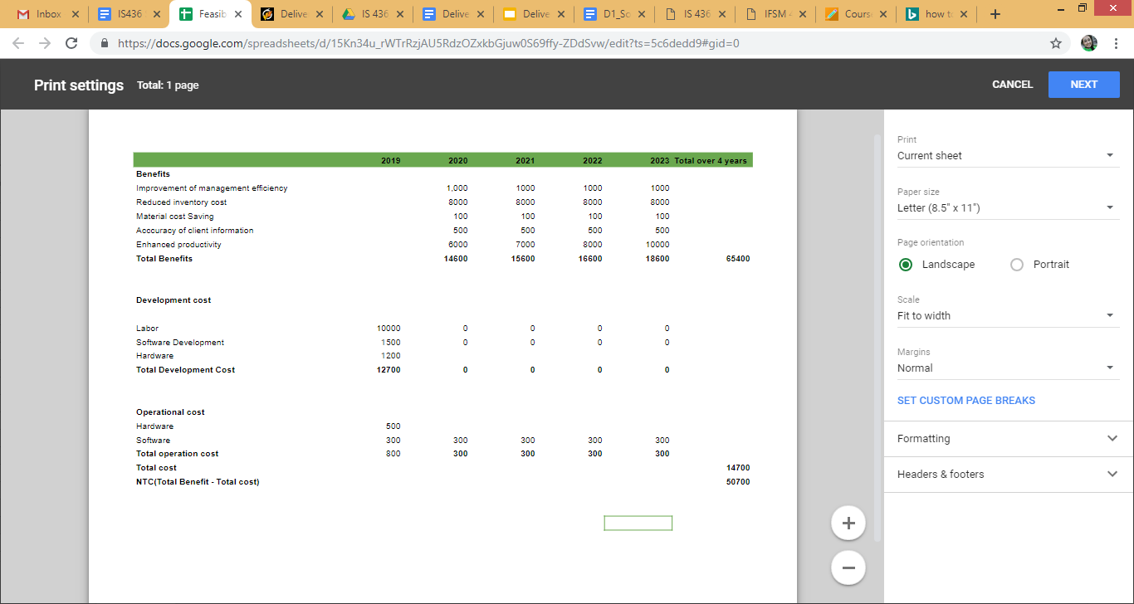

**Team Members and Roles**

* **Krishna Viradia -** Quality Assurance Analyst
  + *Email:* kris26@umbc.edu
  + *Bio:* Senior at UMBC pursuing a B.S. in Information Systems. Also, working at Mosaic Learning as a Quality Assurance Intern. Experience in writing and executing manual text scripts on integration, staging and production on various different projects through JIRA and qTest.
* **Courtney Burns -** Business/System Analyst
  + *Email:* court12@umbc.edu
  + *Bio:* Senior in the Information Systems Undergraduate Program at UMBC. Experience with system analysis, data quality concern management and solution development, customer relationship management. Project leadership experience through work as a student project lead in the Department of Information Technology at UMBC. Intermediate knowledge of front and back-end web development.
* **Sara Nazir -** Quality Assurance Analyst/Editor
  + *Email:* snazir2@umbc.edu
  + *Bio:* Senior in Information System at UMBC. Experience with front end development as well as analyst and quality assurance roles/skills acquired through my internship. Strong writing and speaking skills
* **Wubnyonga Tete -** Project Manager
  + *Email:* wtete1@umbc.edu
  + *Bio:* Information Systems undergraduate student at UMBC. A senior and last semester at UMBC as an undergraduate. Intermediate knowledge in front-end web development. Experience in teamwork and leadership role. Excited to take up this role to learn and perfect myself.
* **Theresa Tomilson -** Developer
  + *Email:* there2@umbc.edu
  + *Bio:* Senior in the Information Systems Undergraduate Program at UMBC. Experience coding and developing the back-end for databases as well as front-end compatibility.
* **Mehak Uddin -** Developer
  + *Email:* muddin1@umbc.edu
  + *Bio:* Senior at UMBC pursuing Information Systems graduating in Spring 2019. Working at Cotiviti as an Associate Data Manager Intern. Duties include: Maintaining, collecting, analyzing, and distributing data to ensure adequacy, accuracy and legitimacy.
* **Nuri Ousman -** Business/System Analyst
  + *Email:* nu2@umbc.edu
  + *Bio:* Senior Information system major with a Mathematics minor. Intermediate Experience in database development and coding.

**Meeting Times/Tentative Schedule**

This schedule is subject to change as the project proceeds. More or less meeting times might be required as agreed upon by the team. Class dates are also meeting dates, but it is not included in the schedule. Emergency meetings can be scheduled when a majority or at least 3 members are free to meet

|  |  |
| --- | --- |
| **DAY** | **DATE** |
| Wednesday | 02/13/2019 |
| Monday | 02/18/2019 |
| Wednesday | 02/20/2019 |
| Wednesday | 02/27/2019 |
| Wednesday | 03/06/2019 |
| Monday | 03/11/2019 |
| Wednesday | 03/13/2019 |
| Monday/Wednesday | Same as above |
| Wednesday | 05/01/2019 (Project Completion) |

**Kanban Flow**

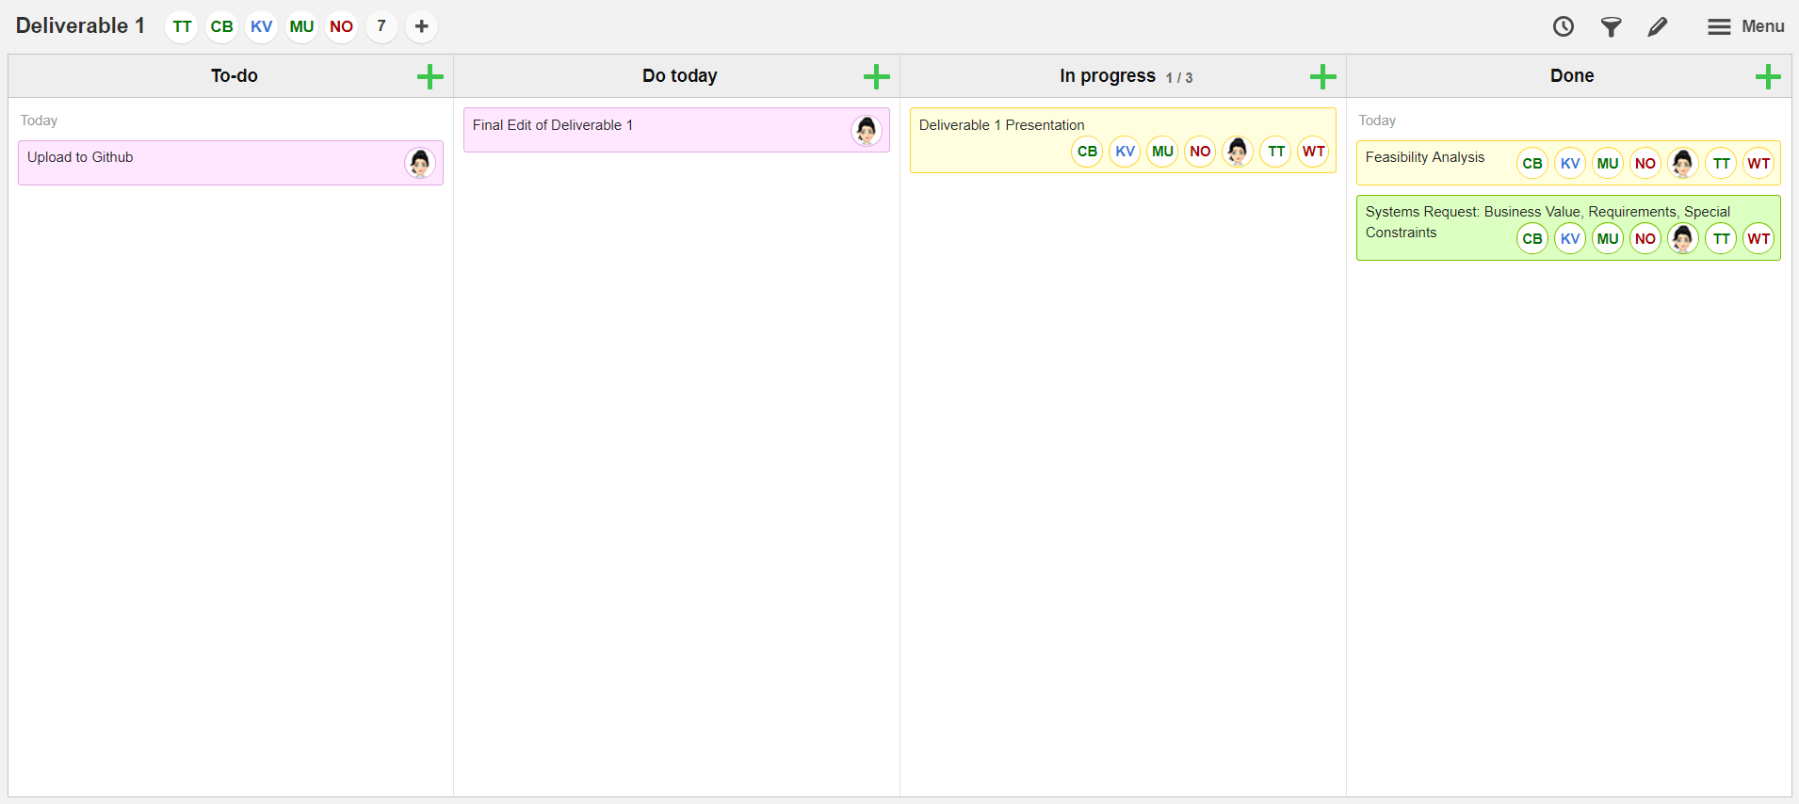

**Deliverable 2:Requirements Definition Document and Use Cases**

Group Name: WebIt

Group Members: Theresa Tomilson, Krishna Viradia, Mehak Uddin, Sara Nazir, Courtney Burns, Nuri Surur, Wubnyonga Tete

Class Name: IS 436 - Structured Systems Analysis and Design

Due Date: 3/28/19

**Functional Requirements**

**Process Oriented**

* The system should allow Authorized person to login.
* The system should allow users to view weekly schedule.
* The system must allow employees to view available dates (calendar) when taking customer order.
* The system must allow employees to view event type when inputting customer order.
* The system should allow payment processing.
* The system must produce reports detailing each reserved event information, which should include event name, customer name, Address, Email, Phone and Cost.

**Information-Oriented**

* The system must retain customer information for 2 years.
* The system must include planned and actual events accomplished per year.
* The system must be able to produce monthly and yearly reports about sales.

**Non-Functional Requirements**

|  |  |
| --- | --- |
| **Operational** | * The system should work on any device * The system should work on any web browser. |
| **Performance** | * Response times (application loading, browser refresh times, etc.) should not take more than 2 minutes. * The system should be easy to use, without any intensive training (at least every new system requires some kind of training or directions). |
| **Security** | * Password length should be 8 or above and must include special character. * Passwords should never be viewable at the point of entry or at any other time. * The invoices can be created and edited by the admin (owner). * Employees should not be allowed to update schedule and their own salary information, and any such attempt should be reported to the administrator. |
| **Cultural and political** | * The system should be able to process invoices and payments in US currencies and foreign currencies. * The company works only around DMV area. |

**Interview Questions**

1. Would you give me a quick overview of your company?

2. Can you describe your role?

3. How do your role and team fit into the company and its goals?

4. How long has your company been in business?

5. How many employees do you have?

6. Is your company revenue available? If so, what is it?

7. Who is your target customer?

8. How does our product help your team or company achieve its objectives?

9. What are some of the problems you face on daily basis?

10. How many people are on your team? What are their roles?

11. How many people will have access to the system?

12. How many orders are received per month?

13. What technical platforms does your company use today?

14. What other IT systems does the organization use today that the new system will need to link to?

15. What computer skills do the users have?

16. Is there anyone else on your team you will like me to talk to?

17. Do you have any feature request or suggestions for our team?

**Questionnaires ( Yes/No)**

1. Do you understand what the idea of ​​the web application is?
2. Do you think the new system will make things better for you?
3. Will you use the new system often?
4. Any other requirements for us?
5. Any software preferences you will like us to use?

**Name of interviewee: Vicky Tawle**

**Company: Vicky Event Planning**

**Name of Interviewer: Wubnyonga Tete**

**Date of Interview: 03/23/2019, Time: 1:00pm**

**Summary of Interview 1**

On behalf of my team, I sat down with Ms. Vicky Tawle on March 23, 2019 for an interview to assist in our requirements gathering and use case analysis. Open and closed ended questions were administered during the interview. An observation was also done after the interview session. It was by luck that she had clients whom she had to work with on that day. Tawle is a very interesting person by nature, and that kind portrays why her clients stick around despite her conventional style of doing things. From the sit down with Tawle, she is not very knowledgeable about software requirements in terms of building a web based database application for her. She is very open to any suggestions as well as she can understand it. She expressed so much interest in the new system and ready to learn to use it once it is done. The main things Tawle emphasized during the interview was a system where she can store customer information, create and edit events. She will also like to be able to create and edit invoice. When asked about other employees accessing the system, she said she can grant an employee access only to view event details and invoice details if she is not around, but she will like to keep things more under her control. Tawle has an understanding of what the system is meant for and what it is expected to do. We also talked about displaying her catalogue on the web page for clients to view before even calling her. She promised herself that will be her next target after she comfortable and stable with the new system. At the end of the interview, I went over the responses to the questions just to make sure nothing was missing or misinterpreted and she vetoed the responses.

The second part of requirements gathering was observation. Tawle had some appointments with some clients. As the observation went, it became very clear that she needs more requirements added to the system than stated before. But those will be future projects. She welcomed her clients in her home office in which we sat for the interview. She brought out a book in which she records client information. She also brought catalogues for the clients to go through to make a choice of the type of setting and sitting they will like for their event. This observation lasted for over two hours because the clients could not really makeup their minds on exactly which setting they want. So they had to take pictures of some the pages catalogue to go home and sleep over. That is a big issue and time consuming, because if clients could view the catalogues online, they could already have an idea of what they have in mind before booking an appointment to have a sit down with her. It will also prevent the back and forth and wasting so much time on appointments. The next clients, were able to make up their mind on what they wanted, and she recorded their information (name, address, phone number, event location, event cost) in book. She had to text the client her bank account information for the client to sent her their payment. This brought up the issue of being able to accept client payment in her office. The clients asked for receipt, which she handed them a hand written invoice. Also, the client had done business with her before, but she was not able to trace the client information in her book record keeping. Trying to flip over pages to trace a client is a challenge, for I had to assist her to flip pages. In all, it was very interesting watching Tawle interact and do business with her clients. As a group, we realized that observation is the best way for information gathering in our case. It was a fun filled experience.

**Name of Interviewee: Kalkidan Gizaw**

**Company: Women's Health Association**

**Name of interviewer: Nuri Surur**

**Date: 03/20/2019 , Time: 6:00 pm**

**Summary of Interview 2**

The interview was conducted on the phone on Mar 20, 2019 with kalkidan Gizaw, the Director of Finance and Business Events at Women's Health non-profit association. We discussed what their company does, what her role is, who their target customers are, how our product can help their company or team and what the functionality of the system should be. Women's Health association is a non-profit organization that focuses on Women’s Health. They provide education for Medical specialist who are looking to have continued education and improve and advance their careers. Kalkidan role is to oversee all revenue and expense aspect of the business and she is in charge to annual events and other events associated with the business. As kalkidan mentioned they have 50 to 60 events every year, so sometimes they have Communication issues with their clients and Meeting the requirement of the projects. She emphasized that how our product can help them to communicate better and have all assigned work visible to everyone and help them to be more efficient. She also suggests that if our product can be accessible to some of their clients and link up to some of their internal system.

**Name of Interviewee: Bobby Moges**

**Company:** **Van Scoyoc Associates Lobbying Firm**

**Name of interviewer: Nuri Surur**

**Date: 03/23/2019, Time: 11:45 am**

**Summary of Interview 3**

The other Interview was conducted on Mar 23, 2019 with Bobby Moges, an Event Coordinator at VSA Lobbying Firm. We met at his office, since it was on the weekend there was only few people at the office. Their office is located at downtown DC where a lot of government offices are. I saw decent conference rooms and halls where they held events. Since they are a Lobbying company they have a lot of out of town clients. After he tour me their offices, we discussed what their company does, what his role is, who their target customers are, how our product can help their company or team and what the functionality of the system should be. Van Scoyoc Associates (VSA) has been developing and executing tailored government affairs strategies for its clients. With a deep bench of policy experts, a network spanning Capitol Hill and the Federal agencies, and the know-how to achieve results, VSA is the first choice for organizations needing assistance in Washington. Bobby’s role is to do legislative research for their clients and mainly coordinate events. As an event coordinator bobby wish if they could have a better system that helps them to be more efficient especially at busy seasons and he thinks our product is the solution for the problem.

**Use Case Diagram**

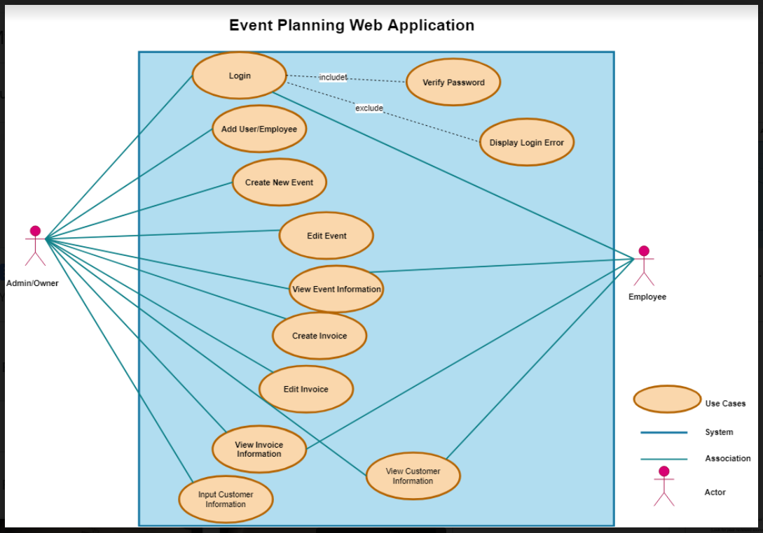

**Use Case Descriptions**

|  |  |  |  |
| --- | --- | --- | --- |
| **Use-case ID:** | 001 | | |
| **Use-case Name:** | Login | | |
| **Created By:** | Sara Nazir | **Last Updated By** | Sara Nazir |
| **Date Created:** | 3/27/19 | **Date Last Updated** | 3/27/19 |
| **Actor:** | Admin and employees | | |
| **Trigger:** | Successful login permits users to access the contents of the database | | |
| **Description:** | The user inputs the proper credentials to access the password protected contents of the database. The system satisfies this request by storing a username and password with admin privileges, and upon correct input, the user will be able to access the contents of the database via the html, php front-end. | | |
| **Preconditions:** | 1. The identity of the admin (owner of the business) is authenticated | | |
| **Post conditions:** | 1. The user is logged in and is able to navigate the front-end of the database and manipulate its contents. 2. Database is notified of the current user log in. | | |
| **Priority:** | High priority (without proper access, the database is inaccessible) | | |
| **Frequency of Use:** | Daily | | |
| **Normal Course of Events:** | 1. System checks for username and password of user if its valid. 2. System display message: “Successfully logged in” 3. When logged out, system displays message: “successfully logged out”. 4. System returns back to the first page | | |
| **Alternative Courses:** | If user does not input information correctly, the user will be sent back to the login page to retry their login, | | |
| **Exceptions:** | 1. Incorrect login of username and password. 2. Username and password does not yet exist in the database | | |
| **Special Requirements:** | Username and password | | |

|  |  |  |  |
| --- | --- | --- | --- |
| **Use-case ID:** | 002 | | |
| **Use-case Name:** | Create New Event | | |
| **Created By:** | Courtney Burns | **Last Updated By** | Courtney Burns |
| **Date Created:** | 3/27/2019 | **Date Last Updated** | 3/27/2019 |
| **Actor:** | Admin/Employee | | |
| **Trigger:** | Customer requests event planning | | |
| **Description:** | The system admin will be able to create a new event where she will input the event information. The system will then store the inputted information into the Event table of the database. | | |
| **Preconditions:** | 1. User must have admin access | | |
| **Post conditions:** | 1. Database is updated with the new event information. 2. The Admin and other employees can access the information for this event. | | |
| **Priority:** | Medium | | |
| **Frequency of Use:** | Every time a new event is created | | |
| **Normal Course of Events:** | 1. Admin creates event. 2. Admin inputs customer ID to link the event to a specific customer. 3. Admin inputs event information. 4. System updates Event table in database with new information. 5. System displays message “Event created”. 6. System opens event information page. | | |
| **Alternative Courses:** | If any information does not meet the correct criteria for that box, the user will not be able to continue onto the next page. | | |
| **Exceptions:** | 1. Customer ID does not exist  * If customer ID does not exist in customer table, system prints error message: “Customer ID does not exist” * System will then ask the user if they would like to retry their query (reinput customer ID) or exit. * System starts on normal course again. | | |
| **Includes:** | N/A | | |
| **Special Requirements:** | N/A | | |
| **Assumptions:** | N/A | | |
| **Notes and Issues:** | N/A | | |

|  |  |  |  |
| --- | --- | --- | --- |
| **Use-case ID:** | 003 | | |
| **Use-case Name:** | Edit Event Information | | |
| **Created By:** | Theresa Tomilson | **Last Updated By** | Theresa Tomilson |
| **Date Created:** | 3/27/19 | **Date Last Updated** | 3/27/19 |
| **Actor:** | Admin/Employee | | |
| **Trigger:** | Business request that requires the user to update event information. | | |
| **Description:** | User specifies which event must be edited to update information. System fulfills this request by pulling specific event record, and allows user to make changes to the event. | | |
| **Preconditions:** | 1. Specified event record must exist 2. User must be logged in and have permissions to edit event info | | |
| **Post conditions:** | 1. Event record is updated in the appropriate columns in the database (specified by the user) | | |
| **Priority:** | High (correct and updatable information is essential to unpredictability of business) | | |
| **Frequency of Use:** | Medium | | |
| **Normal Course of Events:** | 1. User identifies which event record is to be updated via the event ID. 2. User inputs event ID to retrieve information regarding the event 3. User elects to update/edit information 4. User edits event and the appropriate table columns with updated information 5. User saves changes to specific event record. | | |
| **Alternative Courses:** | 1. User can identify a specific event via date of the event and customer ID rather than event ID. 2. User elects to edit/update information of the event. 3. User inputs updated information for the appropriate columns. | | |
| **Exceptions:** | 1. Event no longer exists or has passed.  * System displays message notifying the user that the event requested no longer exists or has passed. * System asks the user if they would like to update another event or exit the function. | | |
| **Assumptions:** | User knows customer ID and event date/event ID. | | |
| **Special Requirements:** | Requires Event ID as well as the updatable information. | | |

|  |  |  |  |
| --- | --- | --- | --- |
| **Use-case ID:** | 004 | | |
| **Use-case Name:** | View Event Information | | |
| **Created By:** | Courtney Burns | **Last Updated By** | Courtney Burns |
| **Date Created:** | 3/27/2019 | **Date Last Updated** | 3/27/2019 |
| **Actor:** | Admin or Employee | | |
| **Description:** | Both Admins and Employees have access to the event information in order to make the event set up and planning and smooth and seamless as possible. Either user must have the Event ID in order to search for the event. Once the ID is inputed, the details of the event will be fetched from the database. | | |
| **Preconditions:** | 1. Must have Event ID in order to find an event | | |
| **Post conditions:** | N/A | | |
| **Priority:** | Medium | | |
| **Frequency of Use:** | Often | | |
| **Normal Course of Events:** | 1. Event ID is entered into system. 2. System uses Event ID to retrieve information from the Event table within the database. 3. System displays information for user. | | |
| **Alternative Courses:** | 1. Instead of inputting Event ID, user can use Event name and date to specify a specific event.  * User can input Event name and date in place of Event ID in the query to display appropriate record. * Only works if user or customer knows their exact Event name and date. | | |
| **Exceptions:** | 1. Event ID does not exist  * System uses Event ID to retrieve information from the Event table within the database. * Event ID is not found. * Error message displays “Event ID not found”. * System will then ask the user if they would like to retry their query (reinput event ID) or exit. * System starts on normal course again. | | |
| **Includes:** | N/A | | |
| **Special Requirements:** | N/A | | |
| **Assumptions:** | User must know the ID number of each event | | |
| **Notes and Issues:** | N/A | | |

|  |  |  |  |
| --- | --- | --- | --- |
| **Use-case ID:** | 005 | | |
| **Use-case Name:** | Input Customer Information | | |
| **Created By:** | Mehak Uddin | **Last Updated By** | Mehak Uddin |
| **Date Created:** | 03/27/19 | **Date Last Updated** | 03/27/19 |
| **Actor:** | Admin/Employee | | |
| **Trigger:** | Creation of new event requires customer information for contacting/updating purposes. | | |
| **Description:** | Allows the user to create new customer records containing information such as name, date of birth, phone number, email, etc…  The user prompts the database to add a new customer. The user inputs information such as customerID, date of birth, phone number, email into database. The user is prompted to complete all required fields such as name, date of birth, and phone number before the customer can be created. The database creates a new record into the appropriate columns. | | |
| **Preconditions:** | 1. User must successfully log in and have permission to input customer information. 2. User must have appropriate customer information. | | |
| **Post conditions:** | 1. Database is updated with the new customer information. 2. Admin is able to edit and input customer information. | | |
| **Priority:** | High (Correct client information is essential in order to contact customer and to keep track of specific customer’s events) | | |
| **Frequency of Use:** | Often (Need to input contact information each time a new client is added) | | |
| **Normal Course of Events:** | 1. Admin creates customer (CustomerID is created) 2. Admin inputs initial customer information (name, date of birth, phone number, email, etc..). 3. System updates customer table in database with customer information. 4. System displays message “Customer has been added.” | | |
| **Alternative Courses:** | 1. Information inputted is not valid. 2. System display error message “The inputted values are not valid. Please try again.” | | |
| **Exceptions:** | 1. User does not have permission to input customer information. 2. User does not exist. | | |
| **Includes:** | N/A | | |
| **Special Requirements:** | N/A | | |
| **Assumptions:** | User must check database to verify customer does not already exist. | | |
| **Notes and Issues:** | N/A | | |

|  |  |  |  |
| --- | --- | --- | --- |
| **Use-case ID:** | 006 | | |
| **Use-case Name:** | View customer information | | |
| **Created By:** | Theresa Tomilson | **Last Updated By** | Theresa Tomilson |
| **Date Created:** | 3/27/19 | **Date Last Updated** | 3/27/19 |
| **Actor:** | Admin/Employee | | |
| **Trigger:** | Business need access to information of a specific customer, but does not need to update or edit any information. | | |
| **Description:** | User specifies the customer information to be retrieved by inputting customer name and phone number. User is provided this information by the customer. System fulfills this request by matching the inputted customer name and phone number to a record in the customer table that matches the inputted name and phone number. The system then queries the corresponding record and information and displays it for the user. | | |
| **Preconditions:** | Customer must exist and the user must have the correct information (name, date of birth) from the customer to be able to pull up the correct record. | | |
| **Post conditions:** | Upon successful query, the database will present all information associated with the customer such as name, date of birth, phone number, etc. | | |
| **Priority:** | High (viewing customer information is essential for the event planner to make appropriate arrangements and to stay in contact with their client) | | |
| **Frequency of Use:** | Often | | |
| **Normal Course of Events:** | 1. User inputs customer name and phone number  * Note: This eliminates duplicates of the same name. Uses name and phone number instead of customer ID as customer ID may not be something easily remembered by either client or planner, so the planner will be able to ask the customer for this information in order to retrieve customer information  1. System retrieves the record associated with the customer name and date of birth and displays it for the user. | | |
| **Alternative Courses:** | 1. Instead of inputting customer name and phone number, user can use customer ID to specify a specific customer.  * User can input customer ID in place of name and date of birth in the query to display appropriate record. * Only works if user or customer knows their exact customer id. | | |
| **Exceptions:** | 1. Customer does not exist  * System displays error message: “Customer does not exist” * System will then ask the user if they would like to retry their query (reinput name and date of birth) or exit. * System starts on normal course again. | | |
| **Includes:** | N/A | | |
| **Special Requirements:** | N/A | | |
| **Assumptions:** | N/A | | |
| **Notes and Issues:** | N/A | | |

|  |  |  |  |
| --- | --- | --- | --- |
| **Use-case ID:** | 007 | | |
| **Use-case Name:** | Create invoice | | |
| **Created By:** | Courtney Burns | **Last Updated By** | Courtney Burns |
| **Date Created:** | 3/27/2019 | **Date Last Updated** | 3/27/2019 |
| **Actor:** | Admin | | |
| **Description:** | Admin specifies who the invoice belongs to via the customer id. Invoices will include event id as well, and contain total cost of the event. System fulfills this request by calculating sum of cost of services rendered. | | |
| **Preconditions:** | 1. User must have admin access | | |
| **Post conditions:** | N/A | | |
| **Priority:** | High (all information within the invoice must be completely accurate to ensure proper customer charges and services rendered) | | |
| **Frequency of Use:** | Often | | |
| **Normal Course of Events:** | 1. Admin inputs the customer ID to link the invoice to a customer within the Customer table. 2. Admin inputs the Event ID to link the invoice to an event within the Event table. 3. Admin inputs the total cost of the event 4. System calculates cost of services rendered 5. System prints message “Invoice complete” | | |
| **Alternative Courses:** | 1. Instead of inputting customer ID, user can use customer name and date of birth to specify as specific customer.  * User can input name and date of birth in place of customer ID in the query to display appropriate record. * Only works if user or customer knows their exact customer id.   2. Instead of inputting event ID, user can use event name and date to specify as specific event.   * User can input event name and date in place of event ID in the query to display appropriate record. * Only works if user or customer knows their exact event name and date. | | |
| **Exceptions:** | 1. Customer does not exist  * Admin inputs the customer ID to link the invoice to a customer within the Customer table. * If Customer ID does not exist in customer table, system prints error message: “Customer ID does not exist” * System will then ask the user if they would like to retry their query (reinput Customer ID) or exit. * System starts on normal course again.   2. Event ID does not exist   * Admin inputs the customer ID to link the invoice to a customer within the Customer table. * Admin inputs the Event ID to link the invoice to an event within the Event table. * If Event ID does not exist in event table, system prints error message: “Event ID does not exist” * System will then ask the user if they would like to retry their query (reinput Event ID) or exit. * System starts on normal course again. | | |
| **Includes:** | N/A | | |
| **Special Requirements:** | N/A | | |
| **Assumptions:** | 1. User knows the Customer and Event IDs | | |
| **Notes and Issues:** | N/A | | |

|  |  |  |  |
| --- | --- | --- | --- |
| **Use-case ID:** | 008 | | |
| **Use-case Name:** | View invoices | | |
| **Created By:** | Mehak Uddin | **Last Updated By** | Mehak Uddin |
| **Date Created:** | 03/27/19 | **Date Last Updated** | 03/27/19 |
| **Actor:** | Admin/Employee | | |
| **Description:** | Using InvoiceID or CustomerID and EventID the system displays the invoice record stored within the database to the user. System fulfills this request by querying the database based on the user input of id, and displays appropriate information. | | |
| **Preconditions:** | 1. InvoiceID or CustomerID and EventID must exist. | | |
| **Post conditions:** | 1. Admin/Employee are able to view invoices | | |
| **Priority:** | High (Invoices being able to be viewed is essential in seeing if it exists for a customer in order to then take action if necessary). | | |
| **Frequency of Use:** | Not often (Only viewed when an invoice exists). | | |
| **Normal Course of Events:** | 1. Admin/Employee inputs the CustomerID and EventID into the system. 2. The system displays the invoice record associated with the specific CustomerID and EventID from the database. | | |
| **Alternative Courses:** | 1. Admin/Employee inputs the InvoiceID into the system. 2. The system displays the invoice record associated with the specific InvoiceID from the database. | | |
| **Exceptions:** | 1. Invoice does not exist. 2. The system displays a message “There are no active invoices for this specific invoiceID.” 3. CustomerID does not exist. 4. EventID does not exist. 5. The system displays a message “There are no active invoices for this customer and event.” | | |
| **Includes:** | CustomerID and/or EventID. | | |
| **Special Requirements:** | N/A | | |
| **Assumptions:** | 1. User knows the InvoiceID, or CustomerID and EventID. | | |
| **Notes and Issues:** | N/A | | |

|  |  |  |  |
| --- | --- | --- | --- |
| **Use-case ID:** | 009 | | |
| **Use-case Name:** | Edit invoices | | |
| **Created By:** | Courtney Burns | **Last Updated By** | Courtney Burns |
| **Date Created:** | 3/27/2019 | **Date Last Updated** | 3/27/2019 |
| **Actor:** | Admin | | |
| **Description:** | If the admin would like to edit any information within the invoices, the system would fulfill that by updating the invoice table with any changes the admin wishes to complete. | | |
| **Preconditions:** | 1. User must have admin access | | |
| **Post conditions:** | N/A | | |
| **Priority:** | High (admin must be able to make immediate changes if necessary to ensure proper information and charges) | | |
| **Frequency of Use:** | Not often (only when invoices are saved incorrectly or charges need to be updated) | | |
| **Normal Course of Events:** | 1. Admin inputs invoice ID 2. System returns information from invoice table matching that invoice ID 3. System displays message “Invoice edited”. 4. System opens invoice information page. | | |
| **Alternative Courses:** | 1. Instead of inputting invoice ID, user can use event ID to specify which event is linked to that invoice.  * User can event ID in place of invoice ID in the query to display appropriate record. * Only works if user or customer knows their exact event ID. | | |
| **Exceptions:** | 1. Invoice does not exist  * If invoice ID does not exist in invoice table, system prints error message: “invoice ID does not exist” * System will then ask the user if they would like to retry their query (reinput invoice ID) or exit. * System starts on normal course again. | | |
| **Includes:** | N/A | | |
| **Special Requirements:** | N/A | | |
| **Assumptions:** | 1. Admin knows the invoice or event IDs | | |
| **Notes and Issues:** | N/A | | |

**Gantt Chart**

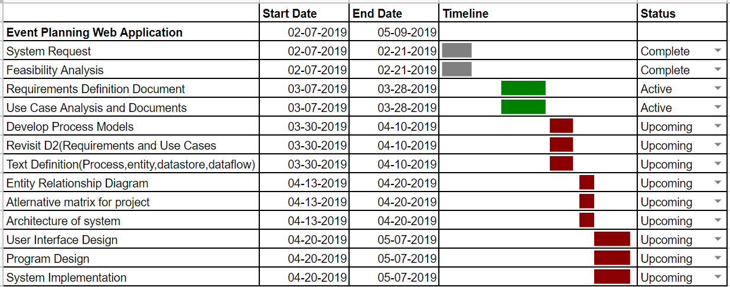

**KanbanFlow at 11:28pm on 3/27/2019**

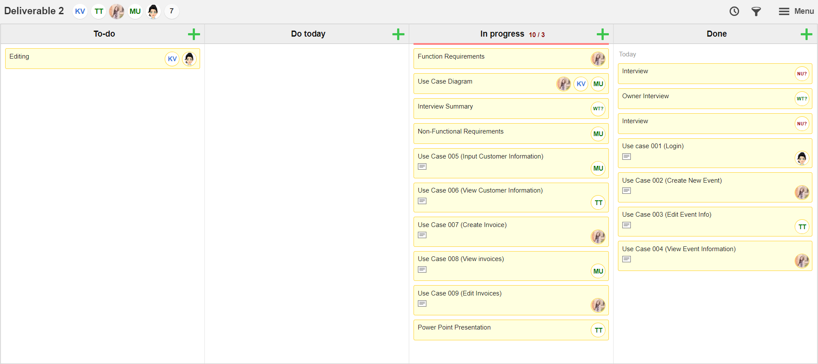

**Appendix**

**Interview Questions and Responses**

**Name of interviewee: Vicky Tawle**

**Company: Vicky Event Planning**

**Name of Interviewer: Wubnyonga Tete**

**Date of Interview: 03/23/2019, Time: 1:00pm**

1. **Would you give me a quick overview of your company?**

I am an event planner. I provide services such as venue booking, catering, music, photography, decorations and more. I do contract outside help from time to time depending on customer requirement. But most of the time I work by myself and I do have an employee (my son) who does most of the box and equipment lifting for me.

2. **Can you describe your role?**

I will basically describe myself as a manager and employee. I make sure I complete task as required and assign responsibilities when I do need additional help.

3. **How do your role and team fit into the company and its goals?**

Customer satisfaction is our main focus, and we do our very best to provide the required services.

4.  **How long has your company been in business?**

4 years

5. **How many employees do you have?**

Myself and my son, which makes two.

6. **Is your company revenue available? If so, what is it?**

Unfortunately, that information is not available at the moment.

7. **Who is your target customer?**

Anyone who is looking to host any kind of party and needs assistance. To cut it short, the general population.

8. **How does our product help your team or company achieve its objectives?**

According to my understanding of what you are building for me, it will help us improve customer satisfaction. Also, help us keep track of our records for easy reference and it will be time saving and less stressful.

9. **What are some of the problems you face on daily basis?**

Tracking down customer records and appointments. Most of the time, I have to be available in my office to be able to go through the calendar to confirm an appointment with a client. I also have to schedule appointments for clients to be able to go through the catalogues to make a decision on what they want.

10. **How many people are on your team? What are their roles?**

Refer to question 1 and 5.

11. **How many people will have access to the system?**

Myself for now, but I think my son will be assisting with that too. Especially when it comes to scheduling.

12. **How many orders are received per month?**

It varies per month, but the least orders I have received in a month is five. Sometimes the number of events depends on how long the event runs and what is requires.

13. **What technical platforms does your company use today?**

We do not use any technical platform. But if you think of it, we use phones to communicate with clients.

14. **What other IT systems does the organization use today that the new system will need to link to?**

No IT system is used

15. **What computer skills do the users have?**

I will consider myself a beginner, because I haven't really done any work that requires using a computer. But I can google and watch videos on YouTube.

16. **Is there anyone else on your team you will like me to talk to?**

You could talk to my son, but unfortunately he is not home at the moment.

17. **Do you have any feature request or suggestions for our team?**

You mentioned earlier that I could display my catalogues on a webpage for customers to view, so they will have an idea of what they are looking for before placing a call through. I will love that to be an addition. Is it possible for your team to do that.

**Interviewer Response:** Oh yes, that is possible. I will talk to my team and get back to you, given the fact that we have a timeframe to accomplish the project.

**Questionnaires ( Yes/No)**

1. Do you understand what the idea of ​​the web application is?  **Yes**
2. Do you think the new system will make things better for you? **Yes**
3. Will you use the new system often? **Yes**
4. Any other requirements for us? **Yes, the system should be easy to use.**
5. Any software preferences you will like us to use? **No**

**Name of Interviewee: Bobby Moges**

**Company:** **Van Scoyoc Associates Lobbying Firm**

**Name of interviewer: Nuri Surur**

**Date: 03/23/2019, Time: 11:45 am**

**1. Would you give me a quick overview of your company?**

For more than 25 years, Van Scoyoc Associates (VSA) has been developing and executing tailored government affairs strategies for its clients. With a deep bench of policy experts, a network spanning Capitol Hill and the Federal agencies, and the know-how to achieve results, VSA is the first choice for organizations needing assistance in Washington.

**2. Can you describe your role?**

My day to day role can be doing some legislative research to event coordinating, when we have clients intown.

**3. How do your role and team fit into the company and its goals?**

The company goal is to give advice and serve our clients with the best or solutions to their problems. Just like my company, my goal is to provide my VP the best information on the subjects they desire.

**4. How long has your company been in business?**

Over 25 years

**5. How many employees do you have?**

Over 60 employees

**6. Is your company revenue available? If so, what is it?**

No

**7. Who is your target customer?**

Our target customers or Our diverse client base has included Fortune 500 companies, cities and small towns, colleges and major research universities, small businesses, foreign governments, charitable organizations, trade associations, and coalitions both large and small.

**8. How does our product help your team or company achieve its objectives?**

It helps us to communicate better and have all assigned work visible to everyone and helps us to be more efficient. You can also help our clients by providing a page where they themselves can get any information they need from us on our page. That way they don’t have to feel like they must talk to me or my colleague.

**9. What are some of the problems you face on daily basis?**

There are so many problems we face each day. One is client development. We are always trying to bring more client to our firm but there are completions from other big farms. Also legislative on the hill is always changing so we must change with it.

**10. How many people are on your team? What are their roles?**

Even though we have over 60 employees, we all have or specialize in certain subjects or areas. So, there are two of us in my team and we both have the same role.

**11. How many people will have access to the system?**

We want all our employees to have access to the system.

**12. How many orders are received per month?**

Orders received per month vary. There are season or time that we are busy. During the period of January to April, August to November orders and productivity goes up. Some Might say, it’s very overwhelming or stressful.

**13. What other IT systems does the organization use today that the new system will need to link to?**

Windows and office 365

**14. What computer skills do the users have?**

The computer skills I and all my coworkers have vary from each other, but most of them will be able to pick up on any new technology. However we all more than comfortable with Windows, power point, excel and offices.

**15. Do you have a preference for which CMS to use? (i.e., WordPress, Joomla, Drupal, Concrete5, Magento, etc.)**

I will prefer WordPress

**16. What information must be on the home page?**

The name of my Company and Login page

**17. Do you require your site to be mobile friendly (responsive design)?**

I would love to, but not Required

**18. Will users need to log in to your site for any reason?**

Yes, I want only me and my employees/teams to access the contents.

**19. Do you need any password protected areas?**

Yes

**20. What kind of content will be put behind password protected areas?**

Contents related to payment, salary information, updating schedule

**21. Will you be offering advertising on the site?**

I would love to, but not required

**22. Do you use a third party for any part of subscription content delivery and/or payment?**

I will use to make a payment

**23. Do you require online chat features?**

I would love to, but not Required

**24. Do you require a database?**

Yes

**25. What specific functionality will it need?**

* produce reports detailing each reserved event
* produce monthly and yearly reports about sales.

**26. What Do You Want People to Do on Your Website?**

* Log in
* Access event calendar
* View Their Schedule
* Share something via email
* Click links to view content
* Take a payment

**27. Is there anyone else on your team you will like me to talk to?**

Not Really

**28. Do you have any feature request or suggestions for**

**our team?**

It will be great if Clients can access the website and if they can register/reserve for an event.

**Name of Interviewee: Kalkidan Gizaw**

**Company: Women's Health Association**

**Name of interviewer: Nuri Surur**

**Date: 03/20/2019 , Time: 6:00 pm**

**1. Would you give me a quick overview of your company?**

A non-profit organization that focuses on Women’s Health. We provide education for Medical specialist who are looking to have continued education and improve and advance their careers..

**2. Can you describe your role?**

Director of Finance and Business Events- I oversee all revenue and expense aspect of the business. And I am also in charge to annual events and other events associated with the business.

**3. How do your role and team fit into the company and its goals?**

We all work together in unison to make the business successful. We have our strategic plans that we follow on a regular to stay on track to accomplish our goals.

**4. How long has your company been in business?**

The nonprofit organization has been around for over 40 years

**5. How many employees do you have?**

Total of 4 employees and couple of contractors

**6. Is your company revenue available? If so, what is it?**

We’re a 1.8 Million Dollar business

**7. Who is your target customer?**

Medical Professionals. Specifically, Physical Therapists

**8. How does our product help your team or company achieve its objectives?**

Your product helps our team with general operation process. It helps us to communicate

better and have all assigned work visible to everyone and helps us to be more efficient.

**9. What are some of the problems you face on daily basis?**

Communication issues with our clients. Making sure projects

are getting completed.

**10. How many people are on your team? What are their roles?**

* Executive Director- Oversees the overall operation of the business, generates revenue and advocate for the business.
* Director of Finance & Business Events- My role
* Director of Marketing- advertises all of our services and products to increase revenue.
* Education Specialist- provides educational logistics for courses we offer across the country.

**11. How many people will have access to the system?**

4 people will have access

**12. How many orders are received per month?**

It depends, Sometimes we are busy sometimes not.

**13. What other IT systems does the organization use today that the new system will need to link to?**

We use different technical platforms which includes: Jotform, Airtable, Expensify, Hubspot, and YM. So It would be great if the new system will link with Airtable.

**14. What computer skills do the users have?**

Users have advanced computer skills. They will be able to pick up on any new technology software that might be presented to them.

**15. Do you have a preference for which CMS to use? (i.e., WordPress, Joomla, Drupal, Concrete5, Magento, etc.)**

WordPress will be great.

**16. What information must be on the home page?**

The name of my Company and Login page

**17. Do you require your site to be mobile friendly (responsive design)?**

I would love to, so that it can be accessible anytime anywhere.

**18. Will users need to log in to your site for any reason?**

Yes, i want only me and my employees/teams to access the contents for security purposes.

**19. Do you need any password protected areas?**

Yes

**20. What kind of content will be put behind password protected areas?**

Contents related to payment, payroll/invoice information, updating schedules and the company sensitive information.

**21. Will you be offering advertising on the site?**

Yes

**22. Do you use a third party for any part of subscription content delivery and/or payment?**

I will use to make a payroll/invoices.

**23. Do you require online chat features?**

I would love to, but not Required

**24. Do you require a database?**

Yes

**25. What specific functionality will it need?**

* produce reports detailing each reserved event
* produce monthly and yearly reports about sales.

**26. What Do You Want People to Do on Your Website?**

* Log in
* Access event calendar
* View Their Schedule
* Share something via email
* Click links to view content
* Take a payment/payroll
* I want my clients to access the website.

**27. Is there anyone else on your team you will like me to talk to?**

Yes, our Marketing Director

**28. Do you have any feature request or suggestions for our team?**

Besides your product being able to link with one of our platforms mentioned earlier, No.

**Deliverable 3: Process Modeling**

Group Name: WebIt

Group Members: Theresa Tomilson, Krishna Viradia, Mehak Uddin, Sara Nazir, Courtney Burns, Nuri Surur, Wubnyonga Tete

Class Name: IS 436 - Structured Systems Analysis and Design

Due Date: 4/17/2019

**Deliverable 2 use case**

**Deliverable 3 use case**

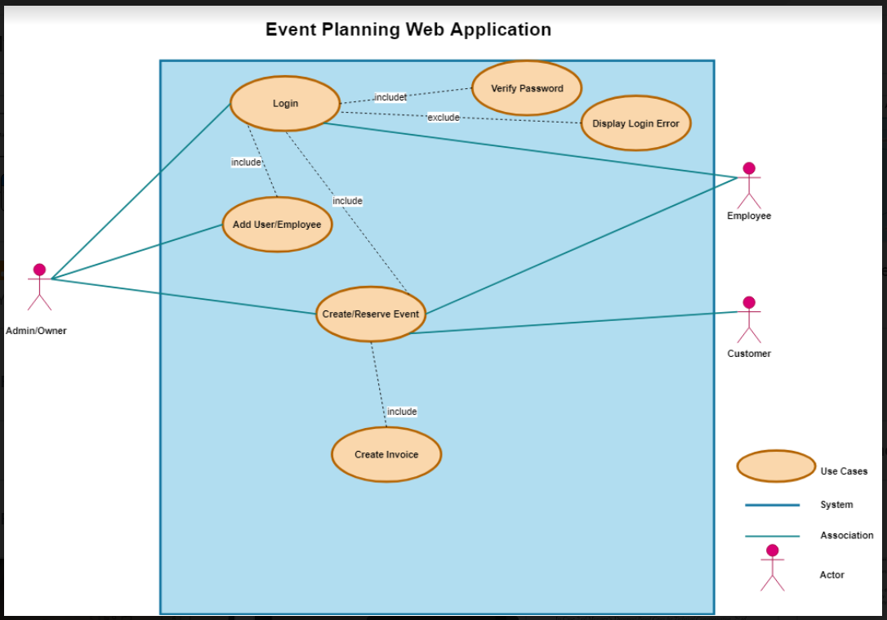

**CONTEXT DIAGRAM**

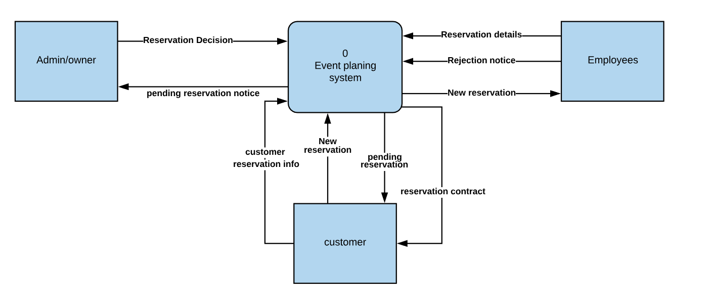

**LEVEL 0 DIAGRAM**

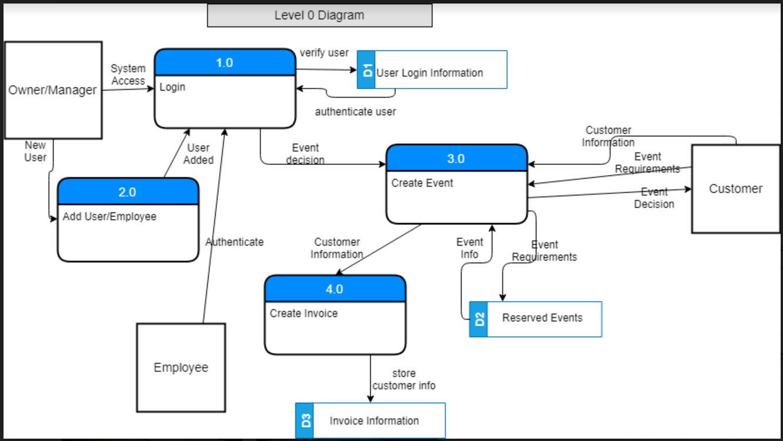

**LEVEL 1 DIAGRAMS**

**Process 1 Level 1 Diagram: Login**

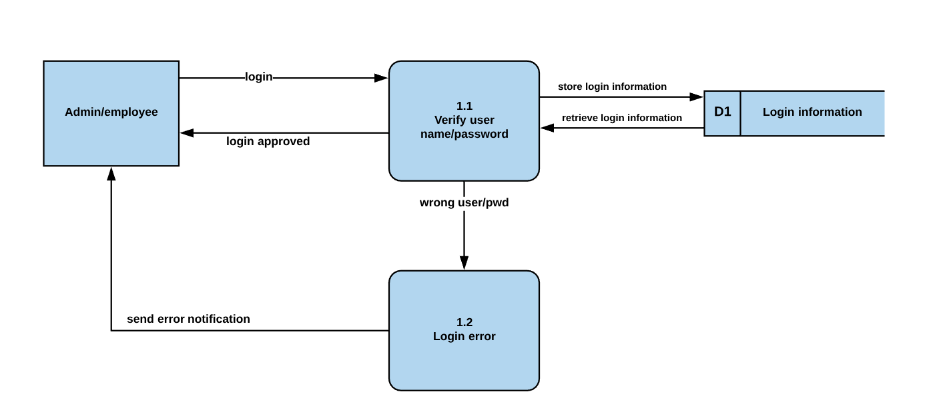

**Process 2 Level 1 Diagram: Add User/Employee**

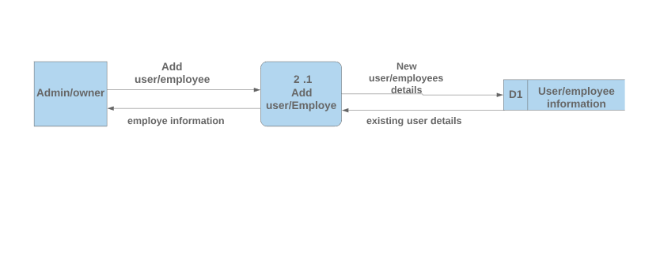

**Process 3 Level 1 Diagram: Create Event**

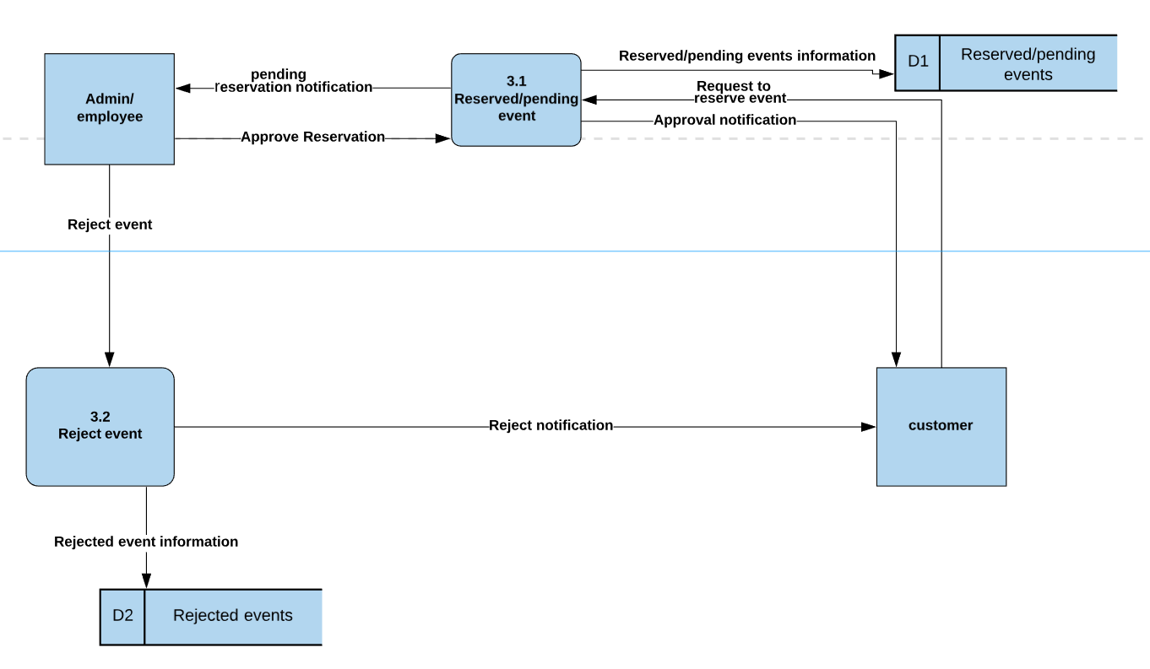

**Process 4 Level 1 Diagram: Create Invoice**

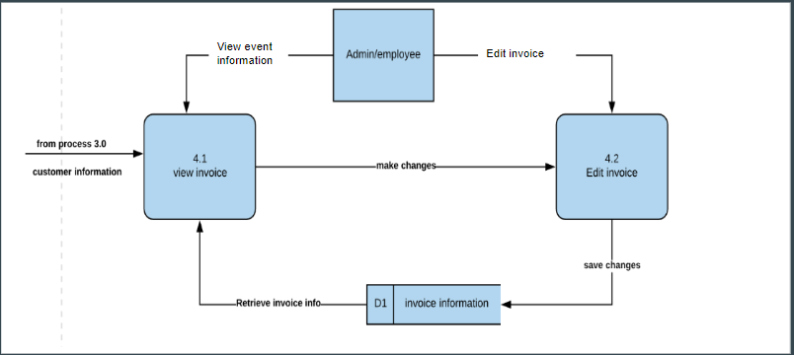

**LEVEL 2 DIAGRAM**

Process 3.1 Level 2 diagram

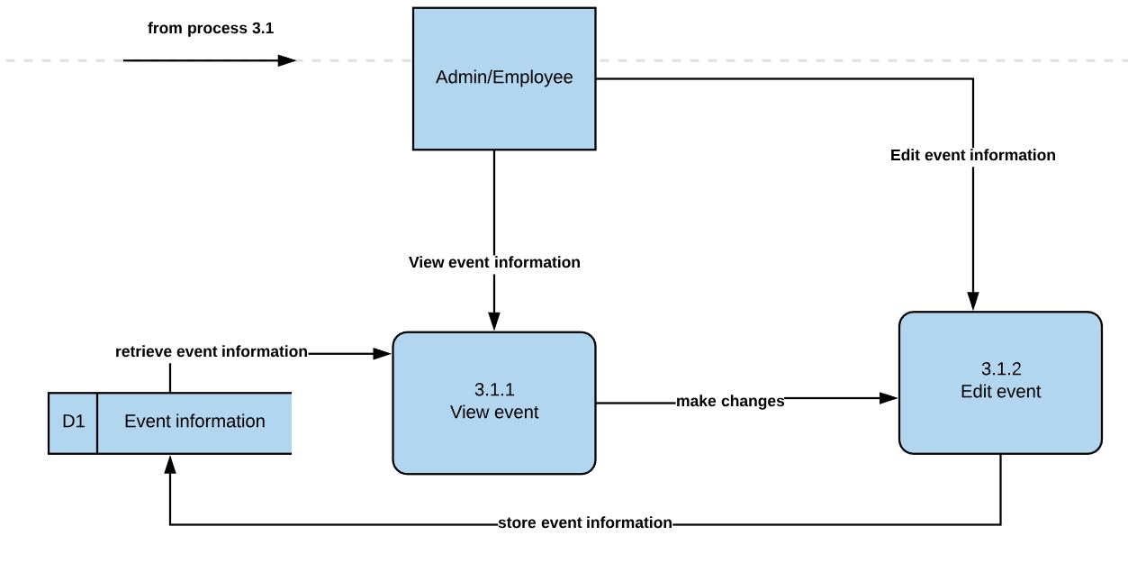

**CASE ENTRY OF PROCESS DESCRIPTION**

|  |  |
| --- | --- |
| Label | Process 1.0 |
| Entry Type | Process |
| Description | This is a description of level 1 Process |
| Process # | 1.1-verify username/pwd |
| Process Description | When Admin/Employee put username and Password, process 1.1 will check if the information is correct by retrieving login information from D1(login information) data store. If it is correct, it will send approval notification for the users and proceed to process 2.0. If it is not correct login information it will proceed to process 1.2(login error). |

|  |  |
| --- | --- |
| Label | Process 1.0 |
| Entry Type | Process |
| Description | This is a description of level 1 Process |
| Process # | 1.2-login error |
| Process Description | When it receives wrong user/password data flow from process 1.1, it will send an error notification to the user saying wrong username/password. |

|  |  |
| --- | --- |
| Label | Process 2.0 |
| Entry Type | Process |
| Description | This is a description of level 1 process |
| Process # | 2.1 - Add User/Employee |
| Process Description | The owner/manager enters new user information. The information can be used by the new user to login. Once the user logs in, the information is retrieved from the user/employee information data flow. If the username and password is valid, the user is granted access to the system, which leads to process 3.0. If the login fails, access to the system is denied and the user is return to Process 1.0, the login page. |

|  |  |
| --- | --- |
| Label | Process 3.0 |
| Entry Type | Process |
| Description | This is a description of level 1 process |
| Process # | 3.1 - Reserved/pending Event |
| Process Description | Once an event is created by a customer, the event is forwarded to the system. The employee can notify the manager of the new event created or the manager can view the new event created if he or she is logged into the system. The event created is compared against the event information data flow to check if there already exists an event on the requested date. If the event requirement is validated, then the event is approved and information sent back to the customer and the event information data flow is updated with the new event information and it moves to process 4.0 (create invoice).  If the event requirements cannot be met, a rejection notice is sent back to the customer and the process goes back to process 3.0 (create event). |

|  |  |
| --- | --- |
| Label | Process 3.0 |
| Entry Type | Process |
| Description | This is a description of level 1 process |
| Process # | 3.2 - Reject Event |
| Process Description | When an admin/employee get a reservation notification, admin/employe will check if the reservation requirements are valid. if it is valid it will send approval notification to process 3.1(reserve event), if not it will send rejection notification to process 3.2(reject event). 3.2 will send a notification to the customers saying event rejected and store rejected information at reject event data store. |

|  |  |
| --- | --- |
| Label | Process 3.1 |
| Entry Type | Process |
| Description | This is a description of level 2 process |
| Process # | 3.1.1 - View Event Info |
| Process Description | Receive reserved event information from 3.1(reserve event) and receive event records from the event information data store. Once it received the event information customers or admin/employees can view the events and it will move to 3.1.1 process (edit event). |

|  |  |
| --- | --- |
| Label | Process 3.1 |
| Entry Type | Process |
| Description | This is a description of level 2 process |
| Process # | 3.1.2 - Edit Event |
| Process Description | Once an event is reserved, reservation information flows to view event process and send the result to process 3.1.2(edit event) using make changes data flow. If Customers/employees/admin edit Event, it will store the edited data at the event information data store. |

|  |  |
| --- | --- |
| Label | Process 4.0 |
| Entry Type | Process |
| Description | This is a description of level 1 process |
| Process # | 4.1 - View Invoice |
| Process Description | Once an event is made, an invoice is created. The admin/employee can access an invoice through view invoice.This gives them the ability to review all information in the invoice. This information is being pulled from the invoice information data store as well as from process 3 where the customer information is populated. |

|  |  |
| --- | --- |
| Label | Process 4.0 |
| Entry Type | Process |
| Description | This is a description of level 1 process |
| Process # | 4.2 - Edit Invoice |
| Process Description | Once an event is made, an invoice is created. The admin/employee can access an invoice through view invoice. This gives them the ability to edit all information in the invoice. This information is being pulled from the invoice information data store as well as from process 3 where the customer information is populated, so if any of that is incorrect, the employee/admin can correct it. |

**Gantt Chart**

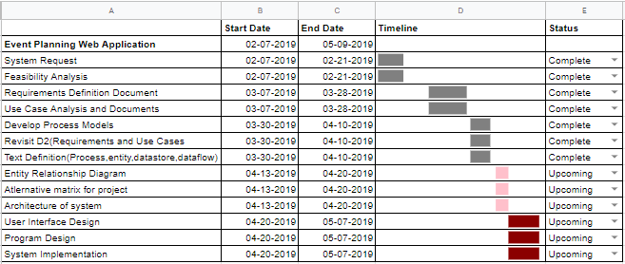

**Deliverable 4: Data Modeling and Starting Design**

Group Name: WebIt

Group Members: Theresa Tomilson, Krishna Viradia, Mehak Uddin, Sara Nazir, Courtney Burns, Nuri Surur, Wubnyonga Tete

Class Name: IS 436 - Structured Systems Analysis and Design

Due Date: 5/09/2019

**ER DIAGRAM**

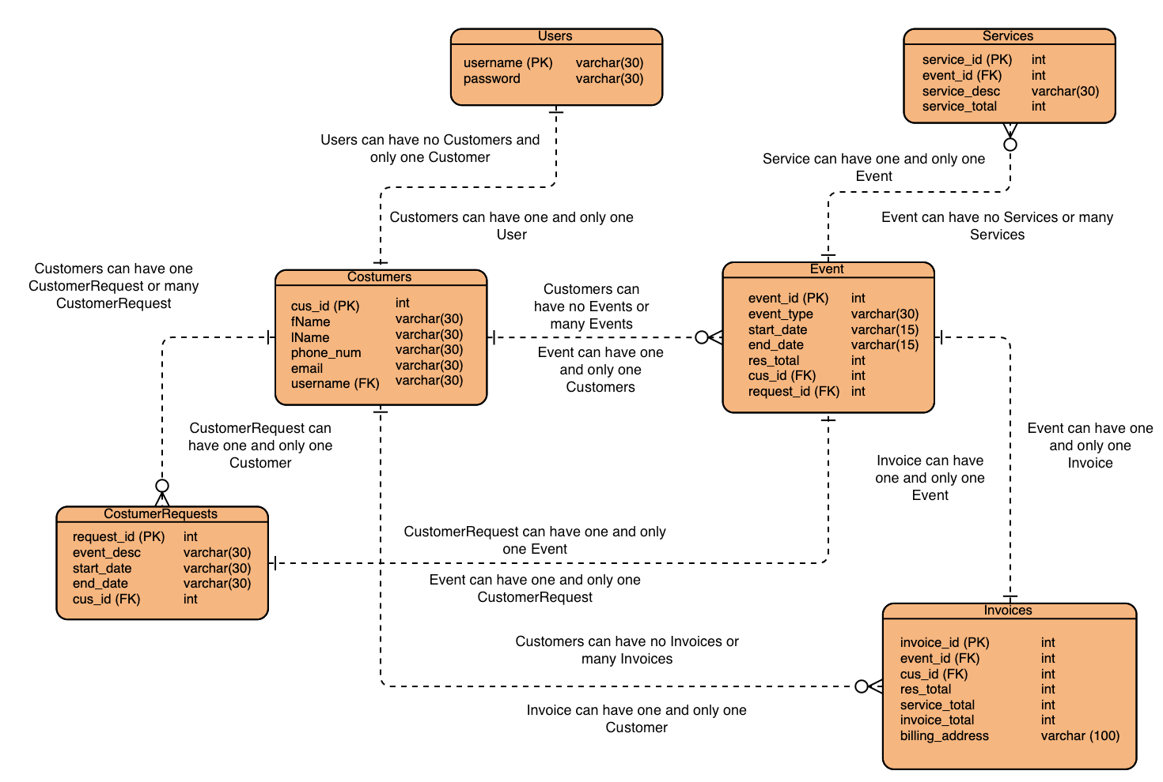

Note: Visual Paradigm (used to make the E-R diagram) did not have *optional on*e relationship and *mandatory one or many* relationship symbols

**Entities and Attributes**

**Users**

* Username, password
* One user registered as one customer
* One customer registered as one user

**Customers**

* Cus_id (pk)**,** fName, lName, phone_num, email, username (fk)
* A customer must request one, but can have many, customer requests for event
* A customer can have many or no invoices associated with them
* A customer can have many or no scheduled events associated with them

**Event (create event)**

* Event_id (Pk), event_type, start_date, end_date, res_total, cus_id (fk), request_id (fk)
* An event must be associated with one and only one customer
* An event must be associated with one and only one customer request
* An event can have many or no services rendered to it.
* An event must be associated with one and only one invoice

**Invoice (create invoice)**

* Invoice_id (pk), event_id(fk), cus_id (fk), res_total, service_total, invoice_total, billing address
* An invoice can belong to one and only one event.
* An invoice can belong to one and only one customer

**Services**

* Service_id (pk), event_id (fk), service_desc, service_total
* Service rendered must belong to one and only one event.

**Alternatives Description**

**MySQL**

The MySQL Database Server is the most popular open-source database. Whether you’re an aspiring web application developer or a person working on an existing database-driven web application like a content management system, e-commerce platform, or blogging platform.

It is very fast, reliable, scalable, and easy to use.

MySQL Server can run comfortably on a desktop or laptop, alongside your other applications, web servers.

The MySQL Database Software is a client/server system that consists of a multi-threaded SQL server that supports different back ends, several different client programs and libraries, administrative tools, and a wide range of application programming interfaces (APIs).

**Oracle**

Oracle database (Oracle DB) is a relational database management system (RDBMS) from the Oracle Corporation.

Oracle DB runs on most major platforms, including Windows, UNIX, Linux, and Mac OS. Different software versions are available, based on requirements and budget.

It is self-driving, self-securing, self-repairing, and designed to eliminate error-prone manual data management.

Oracle is the best choice as a portable DBMS solution. It supports more than 100 hardware platforms and 20 networking protocols.

**MangoDB**

MongoDB is a document-oriented NoSQL database written in the C ++ programming language. Instead of storing information in tables, as with traditional relational databases, MongoDB stores structured information in JSON format with dynamic schemas. This makes integrating information in certain applications much easier and faster.

MongoDB is freely available under the GNU (General Public License). The language drivers are available under an Apache license.

MongoDB comes with links for the main programming languages, like C, C + +, Dart, Erlang, Haskell, Java, JavaScript , etc. These drivers allow you to manipulate the database and its data directly from these languages.

**ALTERNATIVE MATRIX**

**Individual Alternative Matrix**

**Courtney**

|  |  |  |  |  |  |  |  |
| --- | --- | --- | --- | --- | --- | --- | --- |
|  | | **Alternative 1:**  **MySQL** | | **Alternative 2:**  **Oracle** | | **Alternative 3:**  **MongoDB** | |
| **Evaluation Criteria** | **Relative Importance** | **Score** | **Weighted Score** | **Score** | **Weighted Score** | **Score** | **Weighed Score** |
| User Friendly | 5 | 4 | 20 | 3 | 15 | 2 | 10 |
| Cost | 4 | 3 | 12 | 3 | 12 | 2 | 8 |
| Technical Support | 4 | 3 | 12 | 4 | 16 | 3 | 12 |
| Maintenance | 3 | 4 | 12 | 2 | 6 | 2 | 6 |
| Total Score |  | Total Score | 56 | Total Score | 49 | Total Score | 36 |

**Theresa**

|  |  |  |  |  |  |  |  |
| --- | --- | --- | --- | --- | --- | --- | --- |
|  | | **Alternative 1:**  **MySQL** | | **Alternative 2:**  **Oracle** | | **Alternative 3:**  **MongoDB** | |
| **Evaluation Criteria** | **Relative Importance** | **Score** | **Weighted Score** | **Score** | **Weighted Score** | **Score** | **Weighed Score** |
| User Friendly | 5 | 4 | 20 | 3 | 15 | 2 | 10 |
| Cost | 4 | 3 | 12 | 4 | 16 | 2 | 8 |
| Technical Support | 4 | 3 | 12 | 3 | 12 | 2 | 8 |
| Maintenance | 3 | 4 | 12 | 3 | 9 | 2 | 6 |
| Total Score |  | Total Score | 56 | Total Score | 52 | Total Score | 32 |

**Sara**

|  |  |  |  |  |  |  |  |
| --- | --- | --- | --- | --- | --- | --- | --- |
|  | | **Alternative 1:**  **MySQL** | | **Alternative 2:**  **Oracle** | | **Alternative 3:**  **MongoDB** | |
| **Evaluation Criteria** | **Relative Importance** | **Score** | **Weighted Score** | **Score** | **Weighted Score** | **Score** | **Weighed Score** |
| User Friendly | 5 | 4 | 20 | 3 | 15 | 2 | 10 |
| Cost | 4 | 3 | 12 | 4 | 16 | 2 | 8 |
| Technical Support | 4 | 3 | 12 | 4 | 16 | 2 | 8 |
| Maintenance | 3 | 3 | 9 | 4 | 16 | 2 | 6 |
| Total Score |  | Total Score | 53 | Total Score | 63 | Total Score | 32 |

**Krishna**

|  |  |  |  |  |  |  |  |
| --- | --- | --- | --- | --- | --- | --- | --- |
|  | | **Alternative 1:**  **MySQL** | | **Alternative 2:**  **Oracle** | | **Alternative 3:**  **MongoDB** | |
| **Evaluation Criteria** | **Relative Importance** | **Score** | **Weighted Score** | **Score** | **Weighted Score** | **Score** | **Weighed Score** |
| User Friendly | 5 | 4 | 20 | 3 | 15 | 3 | 15 |
| Cost | 4 | 3 | 12 | 3 | 12 | 2 | 8 |
| Technical Support | 4 | 4 | 16 | 3 | 12 | 3 | 12 |
| Maintenance | 4 | 3 | 12 | 3 | 12 | 2 | 8 |
| Total Score |  | Total Score | 60 | Total Score | 51 | Total Score | 43 |

**Mehak**

|  |  |  |  |  |  |  |  |
| --- | --- | --- | --- | --- | --- | --- | --- |
|  | | **Alternative 1:**  **MySQL** | | **Alternative 2:**  **Oracle** | | **Alternative 3:**  **MongoDB** | |
| **Evaluation Criteria** | **Relative Importance** | **Score** | **Weighted Score** | **Score** | **Weighted Score** | **Score** | **Weighed Score** |
| User Friendly | 5 | 4 | 20 | 2 | 10 | 3 | 15 |
| Cost | 4 | 3 | 12 | 3 | 12 | 2 | 8 |
| Technical Support | 4 | 3 | 12 | 3 | 12 | 3 | 12 |
| Maintenance | 3 | 2 | 6 | 3 | 9 | 2 | 6 |
| Total Score |  | Total Score | 50 | Total Score | 43 | Total Score | 41 |

**Tete**

|  |  |  |  |  |  |  |  |
| --- | --- | --- | --- | --- | --- | --- | --- |
|  | | **Alternative 1:**  **MySQL** | | **Alternative 2:**  **Oracle** | | **Alternative 3:**  **MongoDB** | |
| **Evaluation Criteria** | **Relative Importance** | **Score** | **Weighted Score** | **Score** | **Weighted Score** | **Score** | **Weighed Score** |
| User Friendly | 5 | 4 | 20 | 4 | 20 | 3 | 15 |
| Cost | 4 | 4 | 16 | 3 | 12 | 4 | 16 |
| Technical Support | 4 | 3 | 12 | 3 | 12 | 3 | 12 |
| Maintenance | 3 | 4 | 12 | 3 | 9 | 2 | 6 |
| Total Score |  | Total Score | 60 | Total Score | 53 | Total Score | 49 |

**Nuri**

|  |  |  |  |  |  |  |  |
| --- | --- | --- | --- | --- | --- | --- | --- |
|  | | **Alternative 1:**  **MySQL** | | **Alternative 2:**  **Oracle** | | **Alternative 3:**  **MongoDB** | |
| **Evaluation Criteria** | **Relative Importance** | **Score** | **Weighted Score** | **Score** | **Weighted Score** | **Score** | **Weighed Score** |
| User Friendly | 5 | 4 | 20 | 4 | 20 | 3 | 15 |
| Cost | 4 | 4 | 16 | 4 | 16 | 2 | 8 |
| Technical Support | 4 | 3 | 12 | 3 | 12 | 2 | 8 |
| Maintenance | 3 | 3 | 9 | 4 | 12 | 2 | 8 |
| Total Score |  | Total Score | 57 | Total Score | 60 | Total Score | 39 |

**Team Matrix**

|  |  |  |  |  |  |  |  |
| --- | --- | --- | --- | --- | --- | --- | --- |
|  | | **Alternative 1:**  **MySQL** | | **Alternative 2:**  **Oracle** | | **Alternative 3:**  **MongoDB** | |
| Evaluation Criteria | Relative Importance | Score | Weighted Score | Score | Weighted Score | Score | Weighed Score |
| User Friendly | 5 | 4 | 20 | 3 | 15 | 3 | 15 |
| Cost | 4 | 3 | 12 | 4 | 16 | 2 | 8 |
| Technical Support | 4 | 3 | 12 | 3 | 12 | 3 | 12 |
| Maintenance | 3 | 3 | 9 | 3 | 9 | 2 | 6 |
| **Highest Possible Score** | **80** | Total Score | 58 | Total Score | 52 | Total Score | 41 |

**Justification of Team Matrix**

Our team picked MySQL in our final decision matrix. After evaluating each of our main criteria, it was established that MySQL best fit our needs with its flexibility and ease of use. Our client is not as tech savvy so it is very beneficial to have a system that is user friendly and does not require too much maintenance. The way that we scored technical support was based on how much it required and how reliable it was. MySQL would require the least out of our three options which made it a reliable option for our client.

**ARCHITECTURAL DESIGN**

**Operational Requirements**

|  |  |  |
| --- | --- | --- |
| **Requirement** | **Description** | **Example** |
| Technical | * Specific hardware, Software, and Network requirements needed by a business. | The client location will have network connection with real-time updates to the database system |
| System integration | * The system will have to obtain information from and interact with client site and admin site which is connected to the database.   . | Different systems will have to interact to stay up to date with the data within the system. |
| Portability | System will have to operate on mobile platforms | That is, Mobile phones, Tablet, Desktop  Browser 1E11, Chrome  OS supported: windows 7, 8,10, android |
| Maintainability | System will have to withstand the changes in the business and be able to adapt according to business needs. | Changes to documents and other files must be kept in check and up to date. |

**Performance Requirements**

|  |  |  |
| --- | --- | --- |
| Requirement | Description | Example |
| Speed | The amount of time needed for system to perform its functions. | Home page: 3 seconds  Operational pages: 5 seconds |
| Capacity | That is the number of users and request the system can handle | Database size per day: 200GB  Database size per year: 4000GB |
| Reliability/Availability | Amount of uptime/downtime of system | Minimum of 90% uptime, 99% at business/peak hour |

**Cultural/Political Requirements**

|  |  |  |
| --- | --- | --- |
| Requirement | Definition | Example |
| Language | The language the user will need | The system will , operate in English |
| Making Unstated Norms Explicit | Explicitly stating assumptions that differ from country to country | - All payments are in US currencies |

**Security Requirements**

|  |  |  |
| --- | --- | --- |
| Requirement | Definition | Example |
| Access Control | Limitation of accessibility of data | - Only Admin/Owner can create invoices  - Employees can’t update salary or schedule information. |
| Virus control | Controls to protect from viruses | - All files will be checked for viruses |
| Encryption/Authentication | Defines where Authorization is needed for the user | - To protect Customer/User information |

**Decision matrix**

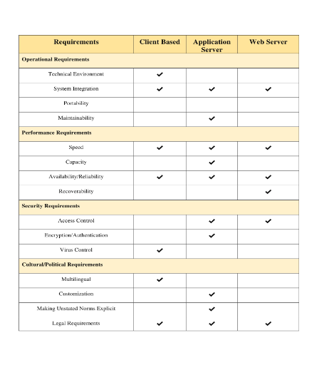

**Hardware and Software Specification**

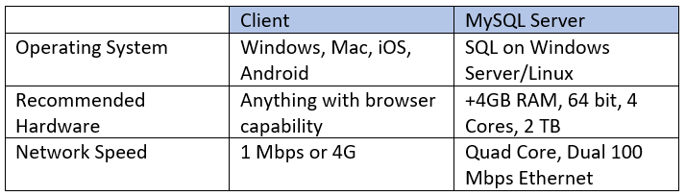

**Updated Project Plan**

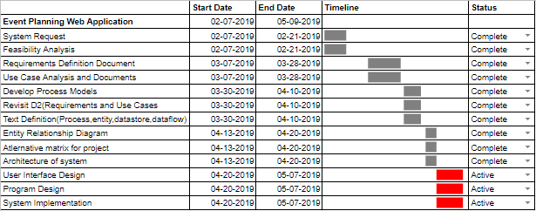

**Deliverable 5: Closing: User Interface Design, Program design and System Implementation**

Group Name: WebIt

Group Members: Theresa Tomilson, Krishna Viradia, Mehak Uddin, Sara Nazir, Courtney Burns, Nuri Surur, Wubnyonga Tete

Class Name: IS 436 - Structured Systems Analysis and Design

Due Date: 5/09/2019

**User Interface Design**

Prototypes:

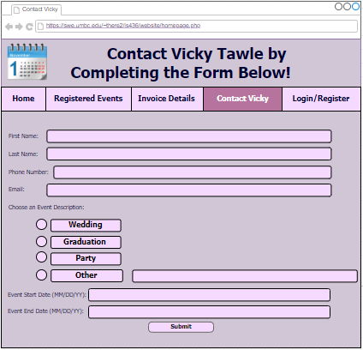

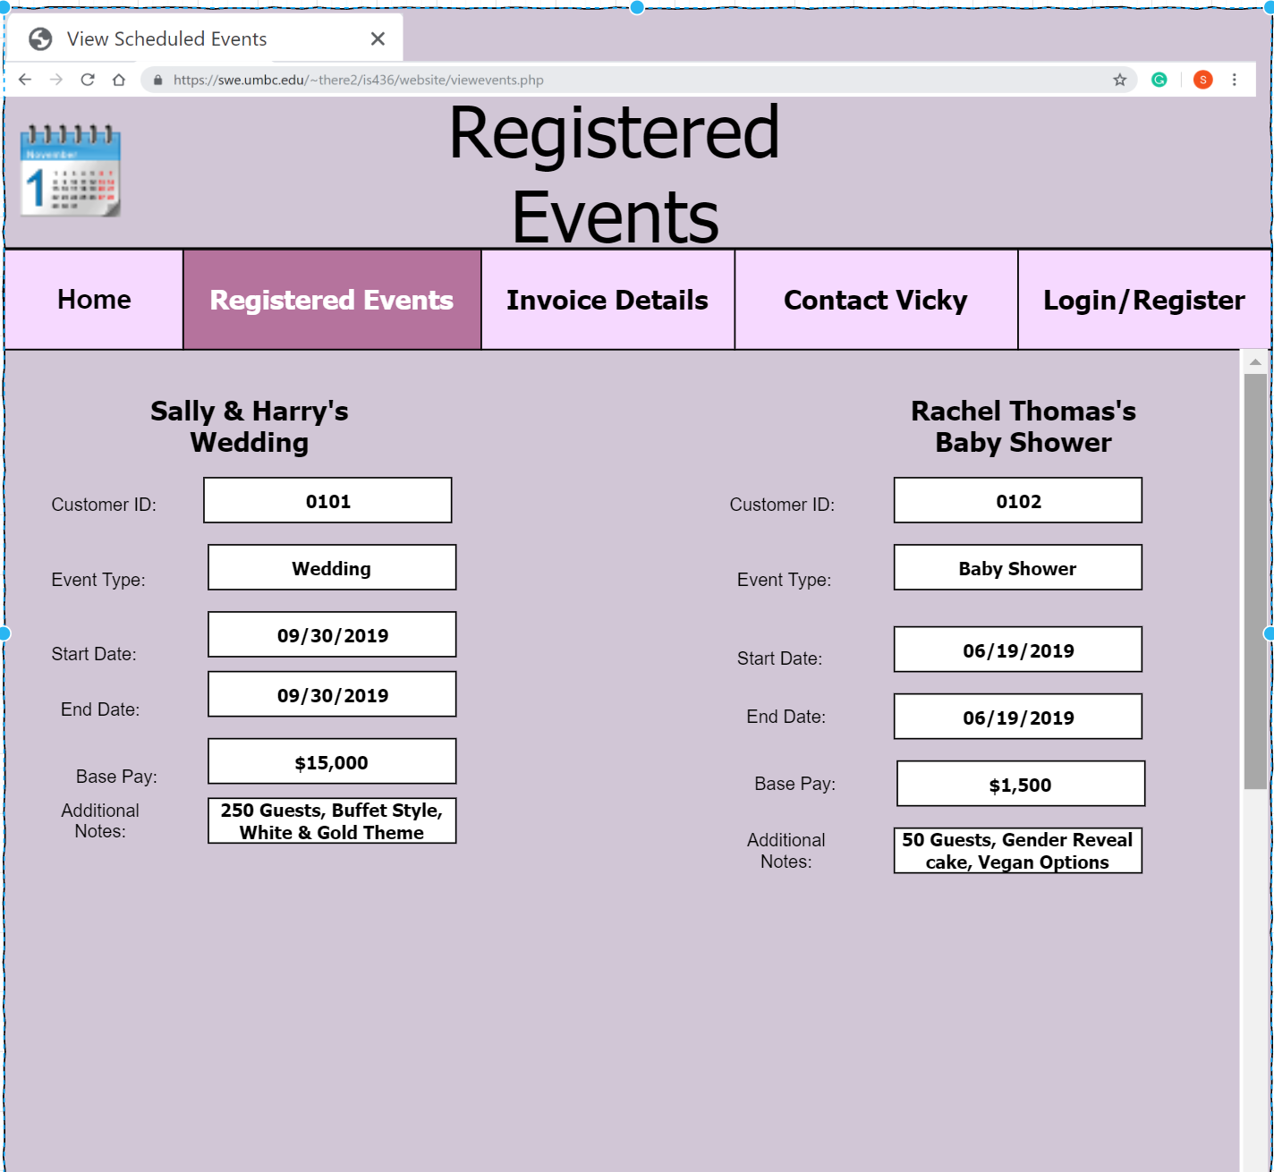

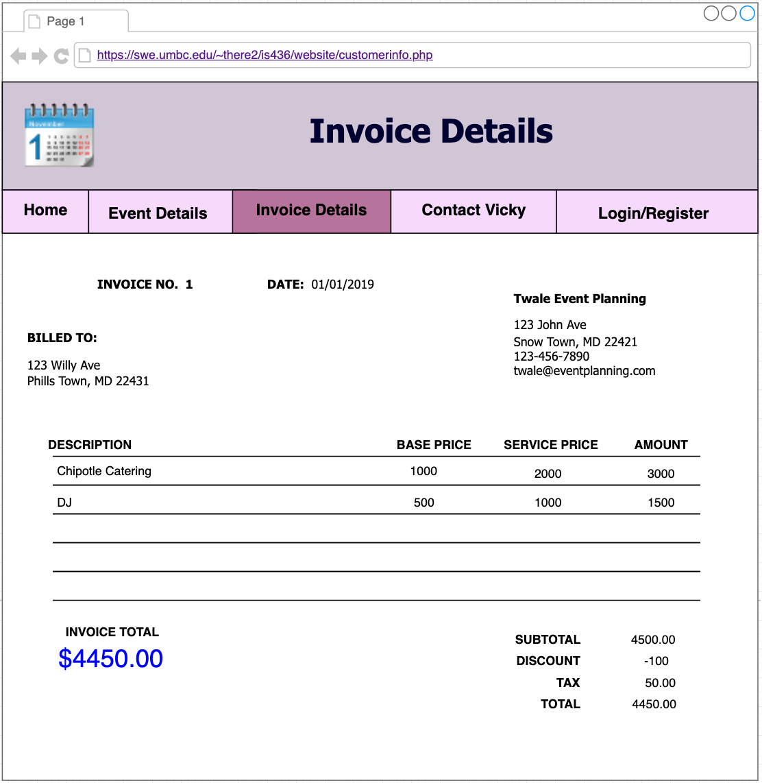

**Interface Standards:**

The interface standards that we would like to follow and make decisions are based upon common elements across individual screens, forms, and reports, interface metaphors, interface objects, interface actions, and interface templates. As a team we have decided to make the html templates have a consistent color theme and similar formats. Having the templates and themes be consistent, allows the user to navigate his/her way through the website with ease. The interface metaphor that we want to follow is having a calendar. The calendar will be used to allow admins and clients to view when they could schedule an event. This is essential to our website since we are designing it for a business that requires a specific date to be booked to plan the event. The interface objects that we would like to follow is having an admin/owner and employees. The users that will be able to access this website are employees and admins/owners. These objects will also have certain access limitations. There are multiple interface actions we would use to follow and make decisions. Some of these include login, register, view customer requests, schedule events, view and edit scheduled events, view and edit current customer information, and view and edit invoice details. The interface template that we would like to follow and make decisions upon involves having a consistent layout for all screens. A consistent layout for all screens makes it easier for the user to learn how to use the website and navigate through it.

**System Requirements**

Software: Web browser, DBMS

Hardware: Anything with browser capability

Platform: HTML, PHP, CSS, OS

**Team Experience with SDLC:**

Throughout the semester, our team had a strong grasp on SDLC and how to implement the different phases in our project. We started off in the planning stage which we thought was very simple since as a team we agreed to create a web application for an event planning business. After that the analysis, design, and implementation phases were easily completed because our group had a concrete project plan from the beginning. Creating a functional web application using relational databases was the most challenging since we only had one developer, Theresa coding the entire site. She made most of the site interactive with login credentials for different users to view certain workflows such as completing a customer survey to viewing/editing event details. The most rewarding part of this project was following through on our team’s vision and seeing the final web application after all the work our team put in. For most of us, we enjoyed creating the system requirements and use case analysis documents because they are very relevant in the IT industry and beneficial to those going into business/technical analyst or project manager careers.

**Updated Project Plan**

